Q1. Write a program that takes the record of 10 students from user in an array and display all
the records. [Define a class student with necessary attributes and behaviors]
Q2.Define a pointer to student class to access the contents of array defined in Q1. Allow user
to search a record in array by means of Rollno
CODE:

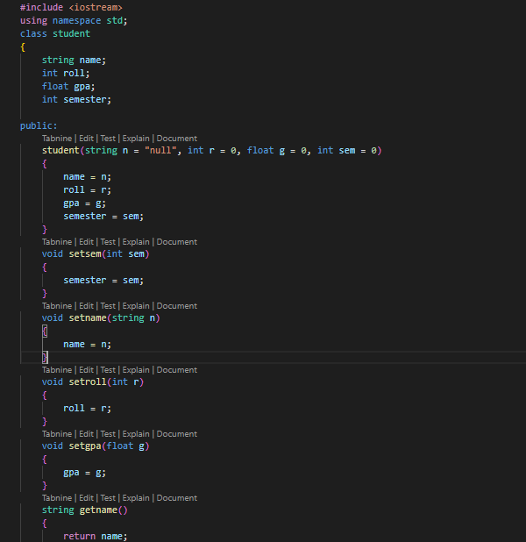
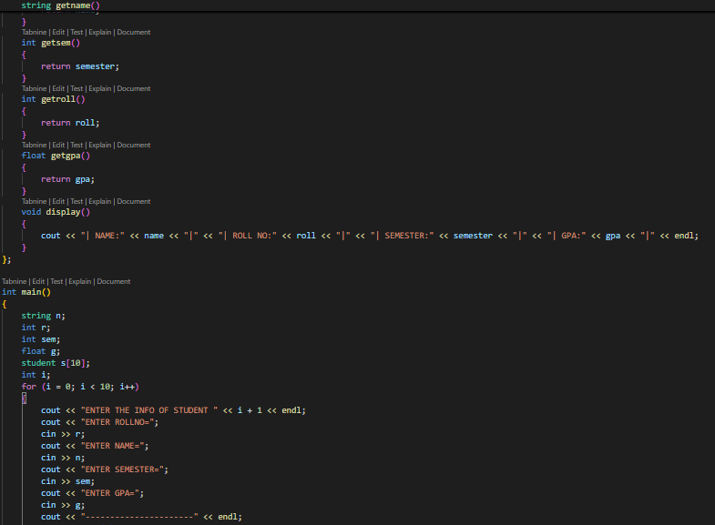
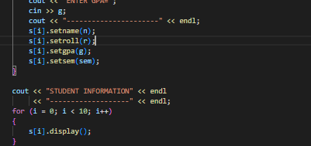

OUTPUT:
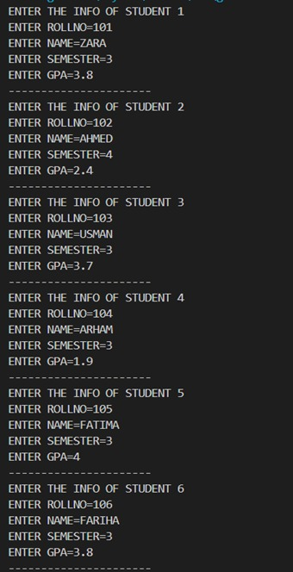
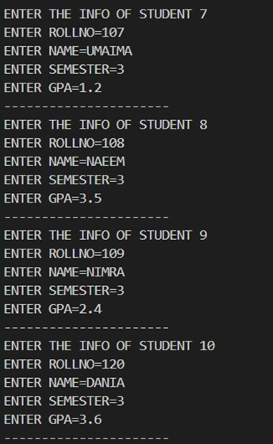
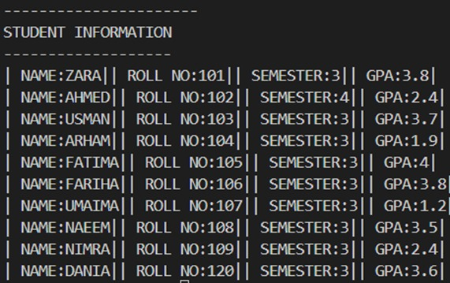
Q2.Define a pointer to student class to access the contents of array defined in Q1. Allow user
to search a record in array by means of Rollno
CODE:
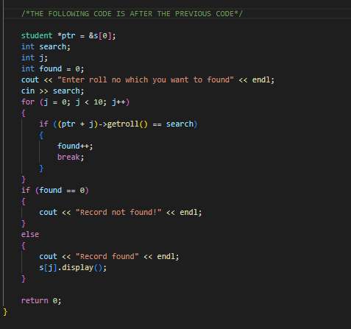
OUTPUT:
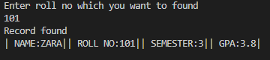

Q3. Develop a class to represent an integer array. The member variables include an integer to
represent the size of array and an integer pointer to represent the address of the first element
of the array. The user is allowed to create an array at runtime using this class. Include
appropriate constructors (parameterized and copy). Also include a method that adds the
contents of array.

CODE:
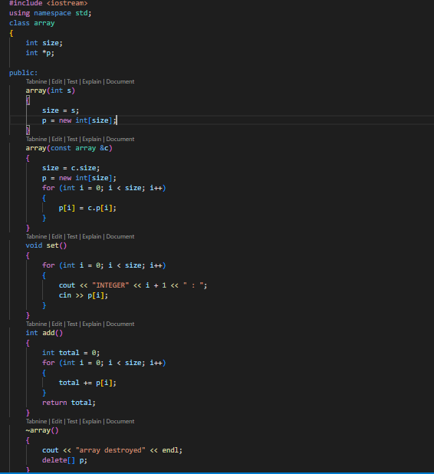

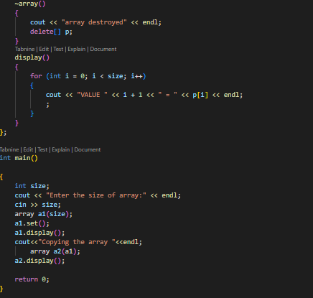
OUTPUT:
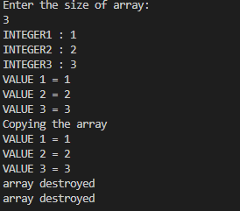

Q4.Consider following code:
class myclass
{int data[2];
public:
int* p;
public:
myclass()
{p=data;}
};
int main()
{ myclass* cp;
cp=new myclass[3];
return 0;
}
How would you access the contents of data of each element of myclass array? Add code in
the above program to do the following:
a. Assign values to array data of each element of myclass array.
b. Display contents of data of each element of myclass array
CODE:
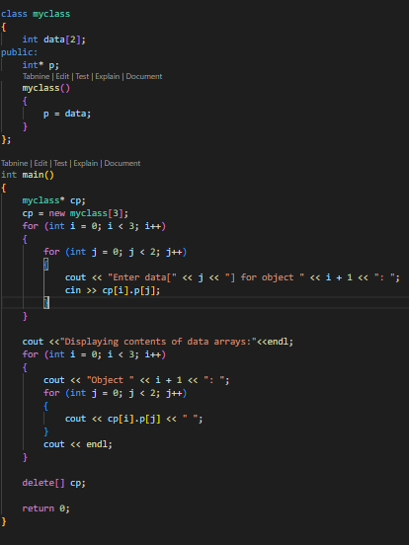
OUTPUT:
